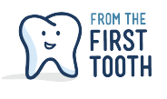

Early Pediatric Oral Health Integration into EMR - CompuGroup
Setting : Federally Qualified Health Center

- Includes all of the Maine Oral Health Risk Assessment questions. Nutritional questions are part of the Let’s Go! healthy weight initiative
- Includes fluoride varnish applied and captures if patient or family declines in the drop down menu
- Includes if fluoride supplements were prescribed or not indicated
- Includes referral to a dentist
- Includes oral health plan and notes for additional documentation

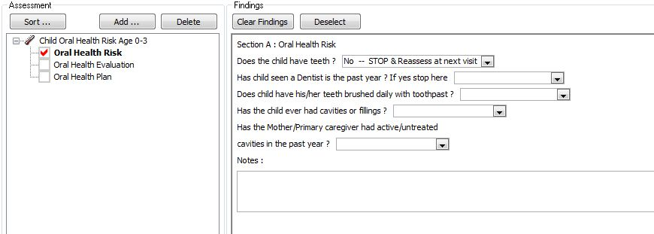

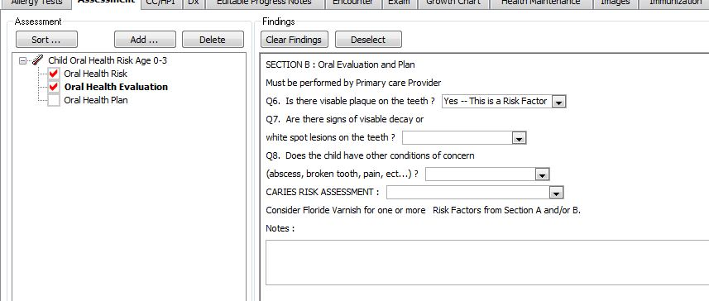
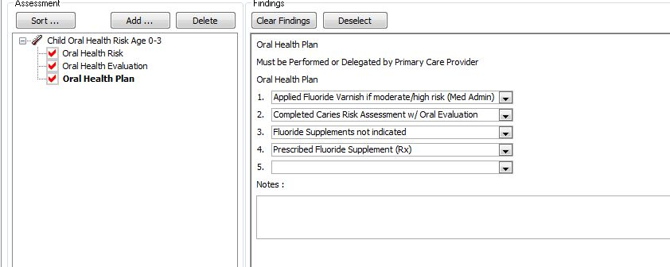
Included in the Oral Health Plan Drop Down Menu
5. Anticipatory Guidance provided
6. Referral to a dentist

