Pediatric Oral Health in Primary Care Practices:
Measuring and Tracking Oral Health Services

Quality improvement is an effective way to improve patient care. In the primary care setting, there are multiple opportunities to develop, test and optimize processes. Quality improvement should be a continual and integral process.
The document is a guide for practices focusing on the integration of early pediatric oral health in primary care practices. This guide outlines four general areas for consideration:
- Defining an Aim Statement
- Identifying Measures and Targets
- Creating a Measurement Plan/Data Collection
- Demonstrating Impact/Reporting

- Defining an Aim Statement
Aim statements should easily answer the question “What are we trying to accomplish?”. Aim statements should be SMART = specific, measureable, achievable, realistic and timely. They should also provide value to your patients.

Specific | Describe on one, precise goal, or intent, to be achieved
Measurable | Are you going to increase or decrease a measure and over what time frame. (Start your aim with increase/decrease and then describe what is going to be measured)
Achievable | Ensure that your practice can overcome barriers in achieving the measured results
Realistic | Consider resources available or competing priorities
Timely | Include specific target dates

Consider the following early pediatric oral health aim statements:
- Increase the percent of children ages 12 through 35 months who receive an oral evaluation from x to y by date
- Increase application of fluoride varnish for children ages 12 through 47 months from x to y by date

- Identifying Measures and Targets

Performance measures can be used as indicators of change that provide feedback during a quality improvement initiative. By breaking your Aim Statement into smaller, concrete measures and targets, it will form a link between strategy and clinical workflow.

The most common quality performance measures used in healthcare setting are:

Outcome Measures | Evaluate patient health as a result of the care received
Process Measures | Determines if the services provided to patients are consistent with routine clinical care

Common measures include:
- Numerator: The number of patients that meet the criteria
- Denominator: The number of patients that are considered eligible
- Exclusion: The number of specific patients who should be subtracted from the denominator

Once you have identified measures, the next step is to set performance targets. Targets help to provide a clear sense of what to aim for.

Consider monitoring the following process measures and targets for early pediatric oral health:
Measures | Suggested Target
Well Child Visit: Percent of well child visits in a specific month/quarter for children ages 12 through 47 months (or other appropriate age range) that have an oral health related/dental procedure code associated with the visit (e.g., D1206 or D0145 or 99188). | 50%
One Year Olds: Percent of children ages 12 through 23 months who have received at least one fluoride varnish. | 80% or higher
4 by 4: Percent of children who receive at least four fluoride varnish applications by age four years. | 45%

- Creating a Measurement Plan/Data Collection
After selecting appropriate measures, it is important to identify the data source, frequency of collection and distribution of data. It is also important to determine who will be responsible for measurement and how the measures will be shared with the team, leadership and the organization.

Data Collection Plan:

Data Sources
How are you going to collect your data? Data sources can include:
- Hospital’s information technology (IT) system or Electronic Health Record (EHR)
- EHR data collection may involve meeting with Information System staff to develop reports and schedule of data extraction
- Sample chart review
- If doing manual chart reviews, keep information required brief, focused and easy to locate within the chart

Sample Plan:
How much data should be collected?
- Full population
- By Primary Payer Type (MaineCare, Commercial, Self-Pay)

How often are you going to collect the data?
- Weekly
- Monthly
- Quarterly
- Yearly

When developing a data plan, specify your measure, especially if requesting a report be run through an EHR. This can be done in a few simple steps.

Step | Example
- Define the measure | Percentage of children, ages 12 through 47 months, who have received fluoride varnish in the primary care setting
- Define eligibility in the patient population | Patients ages 12 through 47 months who have had at least 1 visit in the primary care setting during a specified time
- Set the denominator | Patients ages 12 through 47 months with a visit during a specified time
- Set the numerator | Patients who have had fluoride varnish applied
- Divide the numerator by the denominator to get the performance percentage | (# of patients, ages 12 through 47 months old who have had fluoride varnish applied) divided by (# of patients ages 12 through 47 months old who have had a primary care visit during a specified time)

- Demonstrating Impact/Reporting

Analyzing data over time, through a graphic display, will make it easy to assess the impact of your quality improvement initiative.

Tips when analyzing data:
- Plot data over a specified time period
- Track a few, key measures
- Report and display timely data

Sample Templates
Attached, please find a Microsoft Excel template that you can use to monitor early pediatric oral health in your practice/system. These template spreadsheets can be saved and populated with your data. They will automatically display charts that reflect performance progress.

Sample 1:
Sample 1 displays a line graph, by quarter, of early pediatric oral health provided at well-child visits. This line graph can be replicated for individual providers if data are available.
*Green and red dots indicate if a percentage does not meet or meets and exceeds the specified target. This is done through MS Excel conditional formatting and can be edited to reflect your individual measure targets.
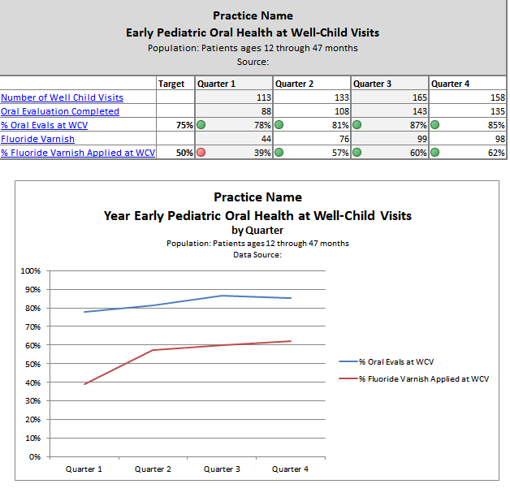

Sample 2:
Sample 2 displays a bar graph, by quarter, of early pediatric oral health provided at well-child visits. This bar graph can be replicated for individual providers if data are available.
*Green and red dots indicate if a percentage does not meet or meets and exceeds the specified target. This is done through MS Excel conditional formatting, and can be edited to reflect your individual measure targets.
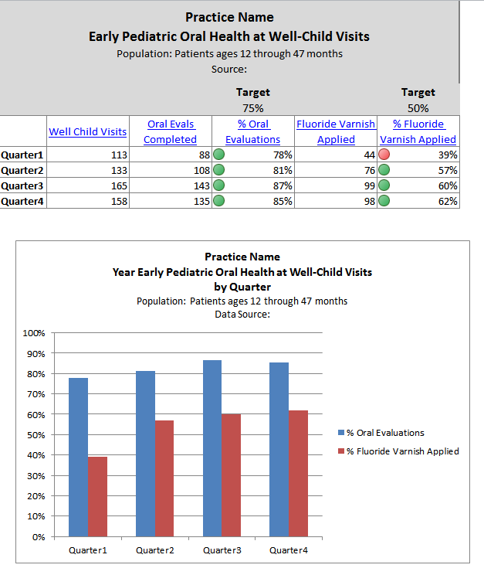

Sample 3:
Sample 3 displays a snapshot of the entire practice’s performance on one chart. The first row provides your practice’s overall performance, with individual provider performance listed on rows below.
Line graphs can be populated by entering practice or provider level data into the chart to the left of the line chart.
*Green and red dots indicate if a percentage does not meet or meets and exceeds the specified target. This is done through MS Excel conditional formatting, and can be edited to reflect your individual measure targets.
